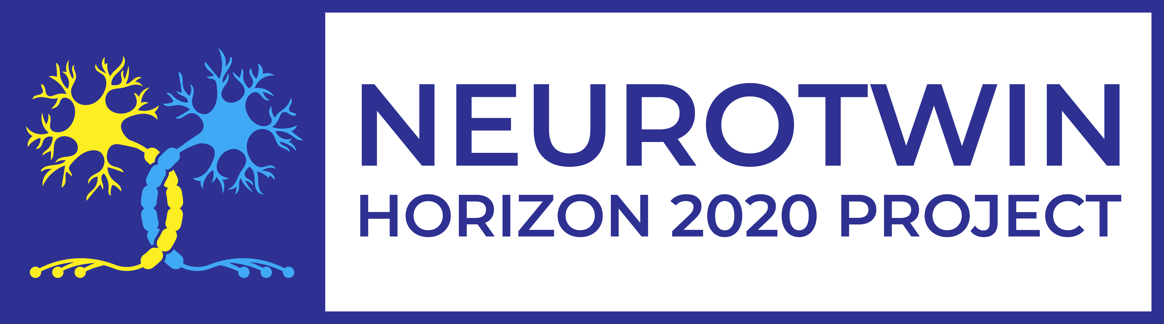 | Pan-European twinning to re-establish world-level Neuroscience Centre in Kiev

Tuesday, October 1st
Venue: Bogomoletz Institute of Physiology (4, Bogomoletz St. 01024 Kyiv)

Workshop: Proposal Writing
9:30 – 10:00 | Registration
10:00 – 10:10 | Opening of the Workshop
 | - Welcoming words Nana Voitenko (BIPH)
10:10 – 10:40 | - What the “Grant” means and how to deal with it  Nana Voitenko, Professor, Bogomoletz Institute of Physiology, Ukraine
10:40 – 11:10 | - Grant application writing: first principles  Dmitri Rusakov, Professor of Neuroscience and Wellcome Trust Principal Fellow, UCL Queen Square Institute of Neurology, University College London, UK
11:10 – 12:00 | H2020 Project Design  - H2020 - Structure  - Development of a Project idea – Project outline  - How to find an appropriate H2020 call for your project idea?  - Writing a project outline and an institutional profile (incl. CVs (short CVs and EUROPASS CVs)  - Setting up the project consortium (How to find appropriate partners (incl. partner search tools))  - Identification & setting up the project objectives and results  - Concept  Gorazd A. Weiss, Senior Expert on Proposal Development, Centre for Social Innovation (ZCI), Austria
12:00– 12:20 | Coffee break
12:20 – 13:30 | Working in Groups: Development of project outline (4 groups/4 pre-identified calls)  - Identification of Calls/ Setting the objectives/list of propose project activities  Gorazd A. Weiss, (ZCI)
13:30 – 14:00 | Standing Working Lunch
14:00 – 15:00 | H2020 application form - structure of the proposal (incl. examples)  - Project impact  - Setting up the project content (incl. work packages (e.g. tasks, sub-tasks activities)  - How to maximise impact: Dissemination and Exploitation  - Project Budget
15:00 – 15:40 | Working in Groups: Development of Project outline (4 groups/4 pre-identified calls)  - Identification of impacts, dissemination and exploitation activities  Gorazd A. Weiss, (ZCI)
15:40 – 16:00 | Presentation to whole class of each elaborated project outlines. Q&A  Gorazd A. Weiss, (ZCI)
16:00 – 16:20 | Coffee break
Workshop: Scientific Writing
16:20 – 16:30 | Opening of the Workshop
 | - Welcoming words by Nana Voitenko, Professor, Bogomoletz Institute of Physiology, Ukraine
16:30 – 17:00 | - Manuscript design: non-trivial challenges in common issues  Georgy Bakalkin, Senior professor at the Department of Pharmaceutical Biosciences, Uppsala University, Sweden
17:00 – 17:30 | - What should be avoided when writing manuscripts  Boris Safronov, Professor, Head of the Neuronal Networks Research Group, Institute of Cellular and Molecular Biology, Portugal
17:30 – 18:00 | - Web of Science Group resources for analyzing scientific data and manuscript preparation  Iryna Tykhonkova, PhD, Clarivate Analytics, Ukraine

Registration is required.

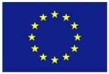 | This project has received funding from the European Union’s H2020 Programme for Coordination and support action under grant agreement no 857562.

Pan-European twinning to re-establish world-level Neuroscience Centre in Kiev

Wednesday, October 2st
Venue: Bogomoletz Institute of Physiology (4, Bogomoletz St. 01024 Kyiv)

Workshop: Knowledge Transfer
9:30 – 10:00 | Registration
10:00 – 10:10 | Opening of the Workshop
 | - Welcoming words by Pavel Belan, Bogomoletz Institute of Physiology, Ukraine
10:10 – 10:55 | - Neuroepigenetics: time for a gold rush  Georgy Bakalkin and Olga Kononenko, Uppsala University, Sweden
10:55 – 11:40 | - Disentangling calcium-driven astrocyte physiology.  Dmitri Rusakov, University College London, UK
11:40– 12:00 | Coffee break
12:00 – 12:45 | - Study of nociceptive processing in the isolated spinal cord and brainstem  Boris Safronov, Institute of Cellular and Molecular Biology, Portugal
12:45 – 13:30 | - Distinct mechanisms of signal processing by projection neurons in spinal cord  Pavel Belan, Bogomoletz Institute of Physiology, Ukraine
13:30 – 14:30 | Standing Working Lunch
14:30 – 15:15 | - Interaction between the spinal cord and the brainstem in the development of chronic pain: modulation by ascending-descending neuronal loop.  S.G. Khasabov, School of Dentistry, University of Minnesota, USA.
15:15 – 16:00 | - The role of lamina X neurons in nociception  Volodymyr Krotov, Bogomoletz Institute of Physiology, Ukraine
16:00 – 16:15 | Coffee break
16:15 – 17:00 | - Monitoring intracellular nanomolar calcium using fluorescence lifetime imaging  Kaiyu Zheng, University College London, UK
17:00 – 18:00 | Lab Tour

Registration is required.

This project has received funding from the European Union’s H2020 Programme for Coordination and support action under grant agreement no 857562.

