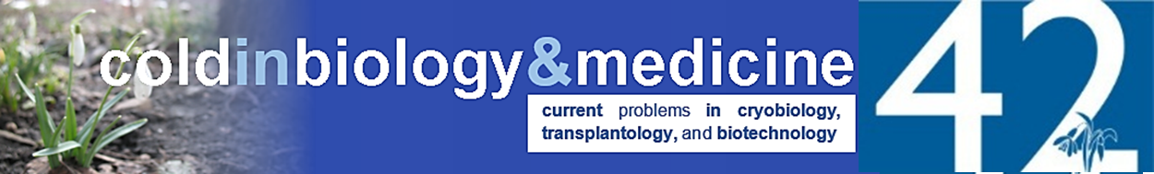

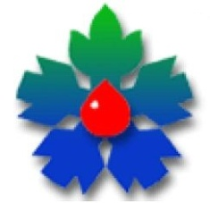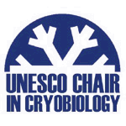Annual Conference of Young Scientists

**"Cold in Biology and Medicine - 2018"**

**May 23 – 24, 2018**

**Kharkov**

**Dear colleagues!**

The Council of Young Scientists together with the Administration of the Institute for Problems of Cryobiology and Cryomedicine of the National Academy   
of Sciences of Ukraine and the UNESCO Chair in Cryobiology are pleased to invite you to participate in the 42nd Annual Conference of Young Scientists   
**"Cold in Biology and Medicine - 2018"** dedicated to the 100th Anniversary of the National Academy of Sciences of Ukraine.

**Participation conditions:**

The scientists, PhD students, University students are welcomed to take part in the conference activity. The best reports of young scientists (up to 35 years inclusive) will be awarded with the diplomas of the UNESCO Chair in Cryobiology.*The main topics are as follows:*

* + mechanisms of damage to biological objects under the influence of low and extremely low temperatures
  + low temperature storage of biological objects (human, animal or plant cells, tissues, organs), including preparation for storage, thawing, cultivation of cells and tissues, etc.
  + the response of biological objects to low temperature;
  + the mechanisms of natural resistance of living systems to the cold and the process of recovery from cold exposure
  + cold adaptation of animals and plants;
  + low temperature in medicine;
  + experimental and clinical transplantation;
  + cryobiological and cryomedical devices;
  + low temperature banks and depositories.

Conference languages:

• Report: Ukrainian, Russian, English;

• Presentation: only English.

To participate at the conference, please register at the conference website: [*coldbiomed.cryo.org.ua*](https://sites.google.com/site/coldinbiologyandmedicine/home)before **April 23, 2018** and send the abstracts to the organizing committee. The abstract will be published in the ***Scopus*** indexed Journal ***“Problems of Cryobiology and Cryomedicine”***. The distant participation at the conference is not foreseen, the abstracts are published if oral report is presented.

Organizing committee address:

Institute for Problems of Cryobiology and Cryomedicine,

23, Pereyaslavskaya str., Kharkov 61016

E-mail: coldbiomed@gmail.com;

Phone: (098) 890 88 93 (Olga Mykhailova)