XVI International Scientific Conference for Students and PhD Students «YOUTH and progress of biology»,
dedicated to the 75th anniversary of the Faculty of Biology
of Ivan Franko National University of Lviv
and 90th anniversary from the birthday of prof. M.P. Derkach
April 27-29, 2020
Dear students and PhD students!

We invite you to take part in the XIV International Scientific Conference for Students and PhD Students “Youth and Progress of Biology”, dedicated to the 75th anniversary of the Faculty of Biology of Ivan Franko National University of Lviv and 90th anniversary from the birthday of prof. M.P. Derkach, that will be held on April 27-29, 2020 in Lviv, Ukraine.

The Conference is organized by the Faculty of Biology of Ivan Franko National University of Lviv, Friends of Lviv University, Inc., USA, Ukrainian Biophysical Society, Ukrainian Physiological Society, MES Ukraine, Institute of Biology and Environmental Protection of Pomeranian University in Slupsk, Poland.

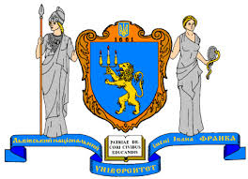  Ivan Franko National University of Lviv | 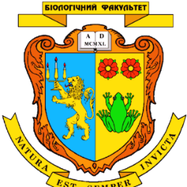  Faculty of Biology of Ivan Franko National University of Lviv | 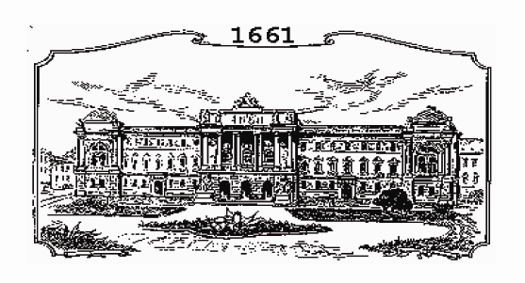  Friends of Lviv University, Inc., USA
Ukrainian Biophysical Society | 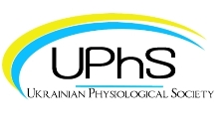  Ukrainian Physiological Society | 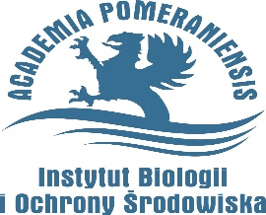  Pomeranian University in Slupsk, Poland

Students and PhD students that perform research in all fields of biology, biomedicine and ecology are invited for participation in the Conference. Materials of the Conference will be published as a Book of Abstracts.

Participants of the Conference can choose one of listed bellow forms of materials presentation – oral report or poster presentation/
The official languages of the conference are Ukrainian and English.

Conference will be held within such sections:
- Biochemistry  - Biophysics  - Botany and Plants Introduction  - Ecology  - Genetics and Biotechnology | - Human and Animal Physiology, Biomedicine  - Microbiology, Virology and Immunology  - Molecular and Cell Biology  - Plant Physiology  - Zoology

Requirements for participation in the conference:
Must be no later than March 10, 2020:
• register through a link:
https://docs.google.com/forms/d/1f1rn_jVJKTnn8VpbK9B_6-MpUPnIt7EyZbziwMBnxtk/edit
• submit abstracts and make payments.

Requirements for Conference abstracts

Abstracts should be represented (submitted) in Ukrainian or English. Abstract size is up to 1 page А4 format, orientation Portrait, all borders – 2 cm, font Times New Roman, type size 12, space 1,0, paragraph – 1.25 cm.

In abstracts in Ukrainian, the annotation in English (5– 6 lines) should be added. No figures, no diagrams are allowed. Literature citation in text should be presented as author name and year of publication in brackets (Orlenko, 2019). Do not use change of register, fonts, text formatting and marking. Organizing Committee reserves the right for general edition of abstracts and rejection them if they do not correspond to subjects and requirements of the Conference.

Demanded abstract form:
Names of all authors (name of the presenting author should be underlined)
TITLE OF ABSTRACT
Official name of scientific institution, where study was carried out
Post address of the institution
e-mail
Abstract text (short content of presentation).
For example:
I. Vanaga, J. Gurkina, O. Treikale, I. Priekule, J. Pugacova
INFLUENCE OF HERACLEUM SOSNOWSKYI CONTROL MEASURES ON WEED DIVERSITY IN AGRICULTURAL FIELDS IN LATVIA
Latvian Plant Protection Research Centre
Lielvardes iela 36/38, Riga, LV1006, Latvia
e-mail: ineta.vanaga@laapc.lv
Abstract text…
File should be saved as *.rtf file and sent to email. Abstract file name must contain the name of the first author (for example – vanaga_abstract).
The receipt of the abstract will be confirmed by a letter to your e-mail address and the payment information and detailed conditions for participation in the conference will be sent immediately. If no confirmation is available, please resubmit within a week of first submitting. The secretariat of the conference submits the received abstracts for review to the specialists of the respective fields. According to the reviewers, the abstracts can be accepted unchanged, with little editing or rejected. The Organizing Committee reserves the right to distribute reports to the sections that will be prepared in preparation for the conference.

To participate in the conference you must pay an organizational fee:
- for Ukrainian participants - 250 UAH. (students), 300 UAH. (graduate students);
- for foreigners - 30 EUR.

Participant fee includes payment for:
- publication of some abstracts,
- conference participant's package,
- certificate of the participant.
The cost of the printed abstract in the amount of the organizational fee is not included and is paid at the request of the participant of the conference additionally (the cost of one copy - 100 UAH). Payment for the travel, accommodation and meals of the participants is made at the expense of the institution sending the business trip or at their own expense.

WARNING! Abstracts will be published only in case of timely payment of the organizational fee. Receipts are considered received if the organizing committee has sent a confirmation of their receipt to your e-mail address. In the absence of confirmation, please resend the scan or photo of the receipt.

Detailed requirements for the presentation of poster and oral presentations will be set out in the second newsletter in February 2020.
E-mail of the conference organizing committee: postup.conf.2020@gmail.com
Telephone of the conference organizing committee +38 (032) 239 4790, +380672845575.
Antonina Tarnovska

Welcome to Lviv!

