Dear Sir/Madam

_______________________________

International Academy of Hypoxia Research and National Academy of Sciences of Ukraine, cordially invite you to participate in the X International symposium “Modern problems of biophysical medicine” which will be held in Kiev, in Bogomoletz Institute of Physiology from 16.05 till 19.05.2018.
Chair of the Organizing Committee
Oleg Krishtal

Organizing committee adress:
Bogomoletz Institute of Physiology,
Bogomoletz st., 4
01024 Kiev-24, Ukraine
Responsible Secretary :
Irina Litovka - litir@biph.kiev.ua

tel: (38044) 256-25-02; 256-24-95,
tel./fax: (38044) 256-24-95; 256-24-77,
E-mail: vadber@biph.kiev.ua
biolag@ukr.net (exhibition)

Topics:
-Biophysical and biological aspects of the influence of environmental factors on the human body and animals;
- Innovative methods of diagnosis prenosological biophysical forms of pathology;
- Biophysical methods of health valeology restoring, sports, clinical and space medicine;
- Modern technologies of nutrition and water regime;
- Spa technology to improve the quality of life
It is necessary to send theses of lecture until 1 February 2018 to organization Committee address in one copy by e-mail.
Theses must be printed in one page (format of А4). Print Type Times New Roman 12, (1.5 interval). The fields of the top are a 2.5 cm, from the right- 1.0 cm, from the left- 2.0 cm, from the bottom- 3.5 cm with a text editor (Word). After addicional Orgcommitee information reporters must send full text for publication. The title of article should be printed by capital letters, after the authors name, name of establishment, city, e-mail. Working languages: Ukrainian, Russian, English.
Cost of theses publication and participation fee is 30 euro. Payment must be sent: to Pluta Irina, 01024, Kyiv-24, Ukraine, (poste restante with a mark “for the publication”).
The exhibition of medical and preventive medical apparatus will operate during realization of symposium. We invite producers and dealers to take part in symposium with reports, publication and demonstration of new developments. The participation fee for the exhibition is 75 euro

Registration card (till 01.02.2018)

Name ________________________
_______________________________
scientific degree_________________
_______________________________
Organization ____________________
_______________________________
e-mail_________________________
Phone/Fax______________________
_______________________________
address_________________________

Hotel? yes no

Single Double

International Hypoxia Research Academy
National Academy of Sciences of Ukraine
Bogomoletz Institute of Physiology

X International Symposium
“Modern problems
of biophysical medicine”

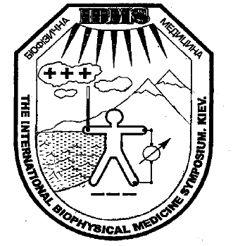

Kiev, Ukraine - 2018

